On the issue of consideration of the application of the Republic of Belarus for obtaining the status of a
Consultative Party

English version provided by the author

On the issue of consideration of the application of the Republic of Belarus for obtaining the status of a Consultative Party
Information Paper submitted by Belarus
1. The summary
In the present document the actual information on separate questions of activity of Belarus in Antarctic in addition to the information stated in the Appendix 1 to inquiry of the Government of Belarus about a recognition of the status of the Advisory Party is represented.
2. Participation in work of public organizations of the Antarctic Treaty
Republic of Belarus is:
- a Contracting Party to the Antarctic Treaty, since 2006;
- a permanent member of the Committee for the Protection of the Environment of the Antarctic, since 2006 ;
- a permanent member of the Council of Managers of National Antarctic Programs, since 2015;
- a permanent member of the Organization of operators of the Intraantarctic aviation flights (DROMLAN), since 2020;
- an associate member of the Scientific Committee for Antarctic Research, since 2018.
From 2006 to 2020, the Republic of Belarus took part in the work:
- of ten Consultative Meetings on the Antarctic Treaty and the Committee for Environmental Protection, where our country presented 23 information documents on various issues of activity in the Antarctic;
- of ten meetings of the Council of Governors of National Antarctic Programs, at which our country presented 9 working documents and 7 presentations;
- of three parliamentary sessions of the Scientific Committee for the Study of the Antarctic in which our country presented 2 reports, 3 messages and 2 presentations.
3. National legislation regulating activities in the Antarctic
From 2006 to 2020, 18 regulatory legal acts were adopted in the Republic of Belarus in relation to the Antarctic: 1 Republican Law, 2 Decrees of the President of the Republic of Belarus, 7 Decrees of the Government of the Republic of Belarus, including accepted in 2020 the Decree of the Government of the Republic of Belarus “On the procedure for reviewing and issuing permits for the activities of legal entities and individual entrepreneurs in the Antarctic Treaty area” and “On the approval of Measure 16” “Amendments to Annex II to the Protocol on Environmental Protection to the Antarctic Treaty "Conservation of Antarctic Fauna and Flora”, and also 4 Decrees of Ministries and 4 bilateral international agreements. In addition, the Decree of the Government of the Republic of Belarus “On Approval of Measure 1 of the “Annex VI to the Protocol on Environmental Protection to the Antarctic Treaty “Liability resulting from environmental emergencies” is in the consultation phase of the Ministries and Departments of the Republic of Belarus.
4. Expeditions activity and creation of the Belarusian scientific station in Antarctica
Regular scientific expeditions of the Republic of Belarus to the Antarctic began in 2006 and are held annually in the summer season. From 2006 to 2021, 13 Belarusian seasonal Antarctic expeditions were organized and conducted, in which 71 Belarusian specialists took part and 6 foreign scientists.
Since 2015, in East Antarctica, Enderby Land near Vechernyaya Mountain, a Belarusian research station has been built on the basis of domestic design developments. Separate objects of the station are shown in the Attachment A (see Figure A.1 – A.9). In the season 2020-2021 the creation of its first stage with the subsequent transition to a year-round operation was almost completed. The limited number of station personnel (11-15 people), the introduction of alternative energy sources (solar energy and wind energy), as well as modern equipment for wastewater treatment, recycling and waste management, guarantee a minimum impact on the Antarctic environment.
In January 2020, representatives of the Australian Antarctic Division (AAD) of the Australian Ministry of Foreign Affairs and Trade inspected the Belarusian Antarctic Station Mountain Evening/Vechernyaya
in accordance with the provisions of the Antarctic Treaty. In the final inspection report, it was noted that the members of the inspection team were impressed by the high level of design and construction of the station, its minimal impact on the landscape, efficient use of solar energy and water, as well as its commitment to scientific research. The inspection team considered the modular and efficient plant design to be a good example of a modern facility and noted that all existing new facilities were fully operational and operating efficiently. The AAD Inspection Team highly appreciated the rational use of existing buildings and the clearance work on the site of the former field base of the Soviet Antarctic Expedition Mountain Evening/Vechernyaya in cooperation with the Russian Federation, and also has noticed, that the construction of the facilities of the Belarusian Antarctic Station is carried out in strict accordance with the Final Comprehensive Environmental Evaluation submitted by the Republic of Belarus at ATCM XXXVIII - CEP XVIII in Sofia (Bulgaria) under IP 39 Construction and Operation of the Belarusian Antarctic Station on mountain Vechernyaya, Enderby Land - Final Comprehensive Assessment environment. The inspection team noted that the plans of the Republic of Belarus for the start of winter activities are at a high level.
5. Scientific activities in the Antarctic
The intentions of the Republic of Belarus for the further research of the Antarctic for the next 5 years are determined by the subprogram “Development of the activities of the Belarusian Antarctic station” of the State program “Scientific and innovative activities of the National Academy of Sciences of Belarus” for 2021-2025. Scientific programs in Antarctica are carried out with the participation of scientific research institutes of the National Academy of Sciences of Belarus (Institute of Physics, Institute of Nature Management, Scientific and Practical Center for Bioresources, Institute of Physiology, Institute of Microbiology, etc.) and the Belarusian State University. Scientific organizations, scientists and specialists from other countries-parties to the Antarctic Treaty also take part in the research.
The Republic of Belarus and Belarusian research organizations have 15 agreements on scientific and technical cooperation in the Antarctic with Governments and organizations from 10 countries-participants of the Antarctic Treaty (Russia, Ukraine, Bulgaria, Turkish Republic, New Zealand, Great Britain, France, Finland, Germany, Canada). The results of scientific activities of Belarusian scientists in Antarctica for the period from 2007 to 2020 have been published in 4 separate monographs (books), more than 20 articles in high-ranking scientific journals (impact factor more than 1.3). More than 110 articles and abstracts have been published in the proceedings of international scientific conferences held in different countries, of which 78 publications have been published in English. The number of publications in collaboration with specialists from other countries is at least 52. More than 60 public lectures on Antarctic topics have been delivered. 3 national exhibitions were held on the activities of the Republic of Belarus in Antarctica. 10 documentary films covering the activities of the Republic of Belarus and international scientific cooperation in Antarctica have been created.
Long-term goals and research plans include the following set of research and monitoring of the state of the natural environment in Antarctica:
- studies of the parameters of atmospheric aerosol and the reflection spectra of the underlying surface;
- carrying out synchronous ground-based measurements and observations of agreed parameters and natural objects in the periods of remote sensing of the area of activity of the BAE by pace satellites;
- studies of the state of the ozonosphere and components of the radiation balance;
- production of standard meteorological observations and climate research;
- measurements of variations of the Earth’s magnetic field;
- studies of living marine, freshwater and terrestrial biological objects, as well as microbiological studies;
- conducting environmental and microbiological monitoring of key environmental parameters in the area of work of the Belarusian Antarctic Expedition;
- medical research and registration of the functional indicators of the expedition staff, as well as indicators of physical activity.
The researches in all areas are provided with modern scientific equipment and instruments. Their photographs and not a complete list are shown in in Attachment B (see Figure B.1 – B.10). There are separate specialized laboratories (biological, atmospheric physics, meteorological bureau, etc.). Photos of scientific laboratories and premises of individual services are shown in Attachment C (see Figure С.1 – С.8).
The plans of environmental protection activities of the Republic of Belarus in Antarctica for the period 2021-2025 provide to equip the station with a domestic wastewater treatment system, a new oil depot and other environmental and technological equipment.
6. Final provisions
The Republic of Belarus fully supports all the provisions of the Antarctic Treaty of December 1, 1959, the Protocol on Environmental Protection to the Antarctic Treaty of October 4, 1991 with five appendices, and the Recommendations and Measures of the Antarctic Treaty Consultative Meetings that entered into force, and expresses its readiness, as before, to follow such basic principles of the Antarctic Treaty of 1959 and the Protocol on Environmental Protection to the Antarctic Treaty of 1991 as support for the peaceful coexistence of Antarctica, development of international cooperation, freedom of research and environmental protection in Antarctica.
Based on the above, we believe that the current activities of our State in the Antarctic meet the necessary criteria for the Consultative Parties to the Antarctic Treaty, which are set out in Article IX of the Antarctic Treaty of 1959 and Decision 2 of the Fortieth Antarctic Treaty Consultative Meeting Guidelines for the Provision of the Status of a Consultative Party (May 22 - June 1, 2017, Beijing, China).
We express confidence, that in a question of an estimation of scientific and logistic activity of our country in Antarctic the Advisory Parties will show a constructive approach and objectivity according to spirit and principles of the Antarctic Treaty.

Attachment А
Individual objects of the Belarusian Antarctic station Mountain Evening/Vechernyaya
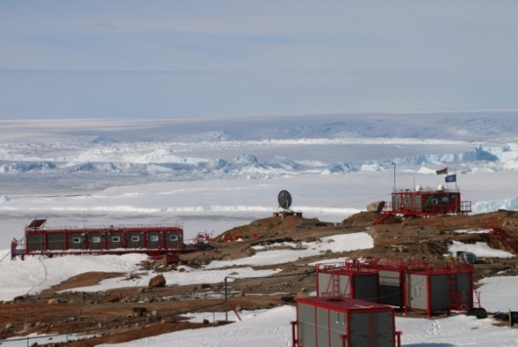  Figure А.1 - General view of the station | 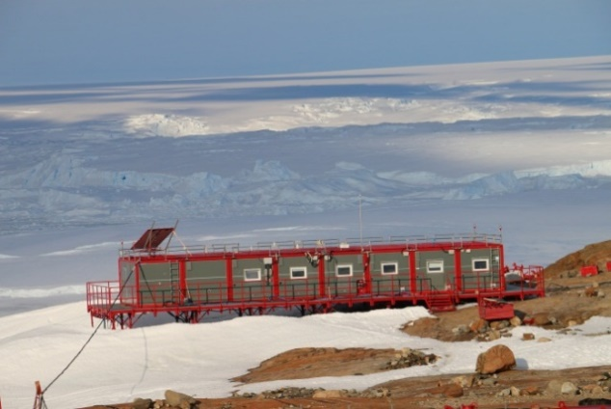  Figure А.2 - Laboratory-living module
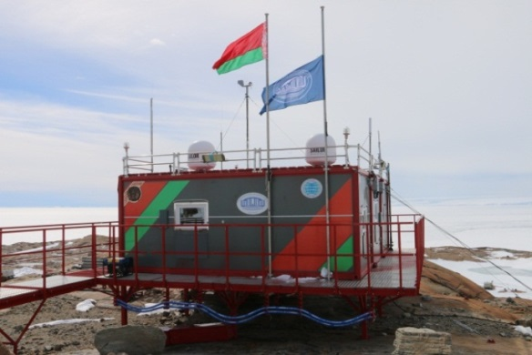  Figure А.3 - Control, communication and navigation module | 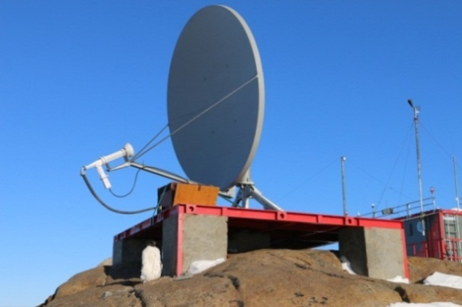  Figure А.4 – Satellite complex VSAT
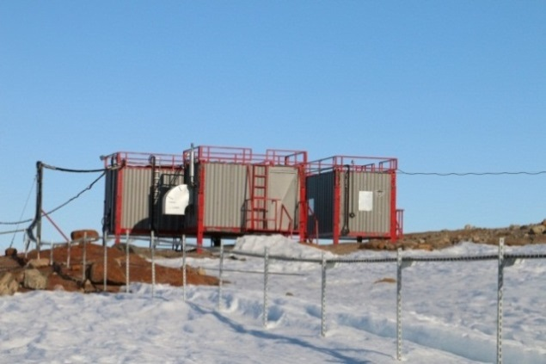  Figure А.5 - Diesel power plant complex | 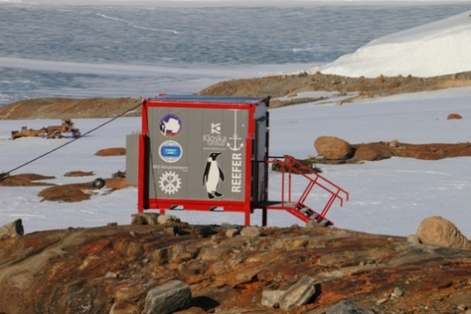  Figure А.6 - Refrigerator container

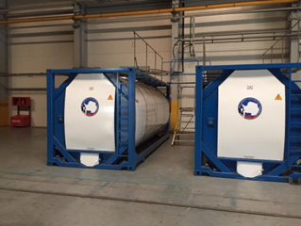  Figure А.7 - Isotainer fuel storage | 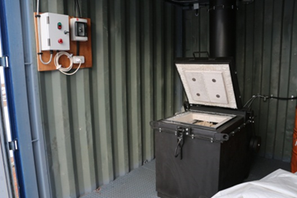  Figure А.8 - Incinerator IU-32 | Figure А.9 - Barrel press HSM FP 3000

Attachment В
Instruments and equipment for scientific research at the Belarusian Antarctic Station Mountain Evening/Vechernyaya
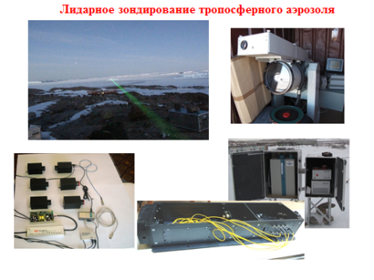  Figure В.1 – Lidar sounding of  tropospheric aerosol | 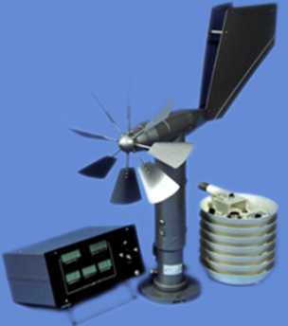  Figure В.2 - Automatic  meteorological station М-49М
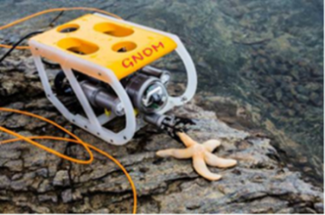  Figure В.3 - Unmanned underwater  vehicle GNOM | 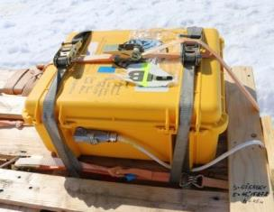  Figure В.4 - Hydrological  thermo-scraper SIMBA
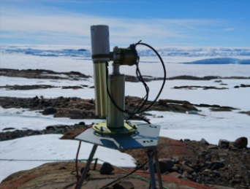  Figure В.5 - Solar photometer  CIMEL CE 318N-EBM9 | 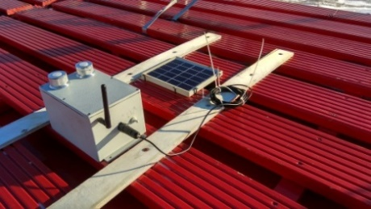  Figure В.6 - Ultraviolet spectroradio  meter PION-F
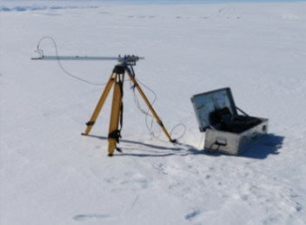  Figure В.7 - Spectral  albedometer AS-A | 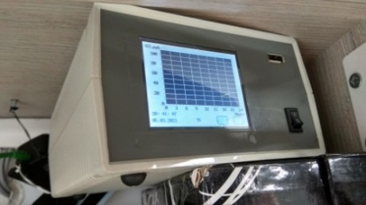  Figure В.8 - Surface ozone meter  PION-PO
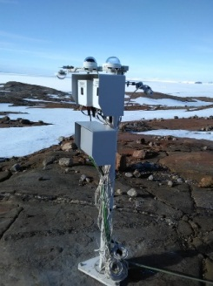  Figure В.9 - Automatic  actinometric station  PELENG CF-16 | 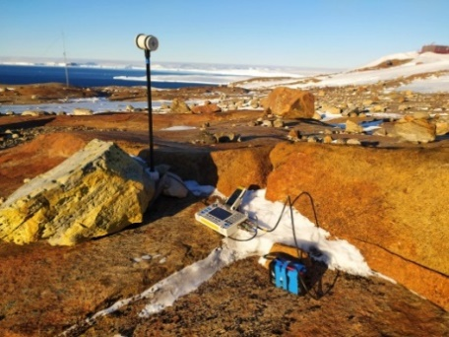  Figure В.10 - Magnetic variation  station MMPOS-1

Attachment С
Scientific laboratories and individual rooms of the Belarusian Antarctic Station Mountain Evening/Vechernyaya
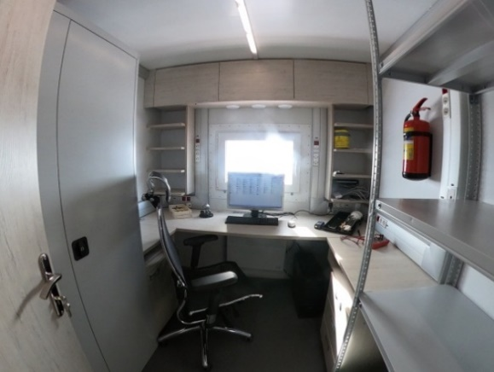  Figure С.1 – Meteorological office | 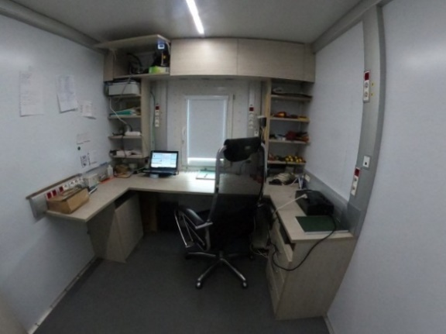  Figure С.2 - Atmospheric physics laboratory
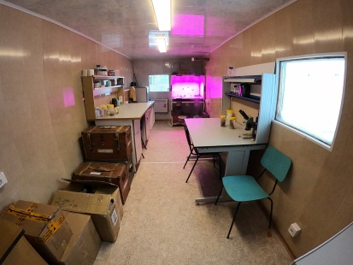  Figure С.3 - Biological laboratory | 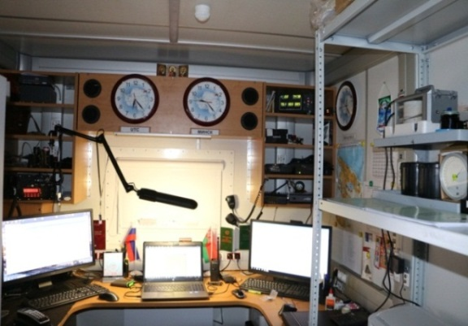  Figure С.4 - Control, communication and  navigation center
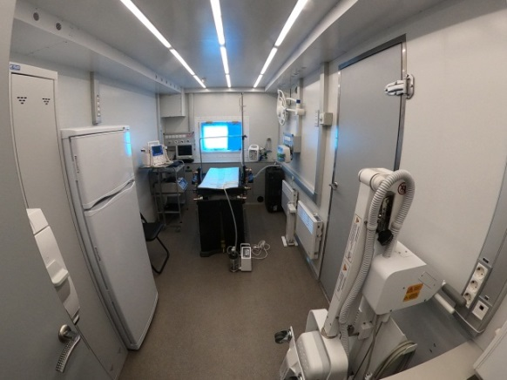  Figure С.5 - Operational and surgical block | 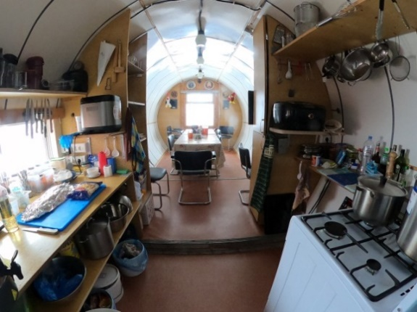  Figure С.6 - Mess-room
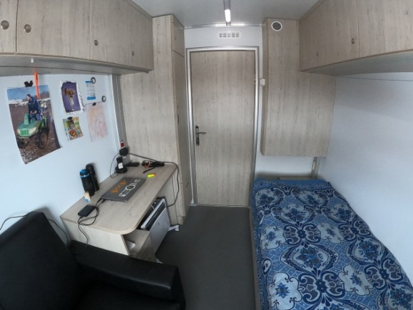  Figure С.7 - Living cabin | 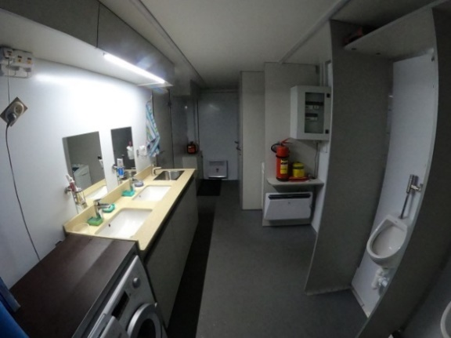  Figure С.8 - Sanitary and hygienic section

