Extension of the Use of Turkish Scientific Research Camp

Extension of the Use of Turkish Scientific Research Camp
Background Paper submitted by Turkey
Summary
This paper gives information on the extension of the usage of the temporary research camp of Turkey, which was aimed to be used until 2022/2023 season.
Introduction
A scientific research camp was established on Horseshoe Island in February 2019 during the 3rd Turkish Antarctic Expedition (TAE-3) to support the polar research field studies. Three 20-feet container-sized modules were installed on the Lystad Bay coast of the Island to be used for different purposes. The first module is used as a workshop and storage for equipment & spare parts. The middle container is employed as a dormitory which can accommodate up to 8 people and can also be used as an office. The third module is a kitchen where people can eat and rest, which can also be organized to be used as a laboratory.
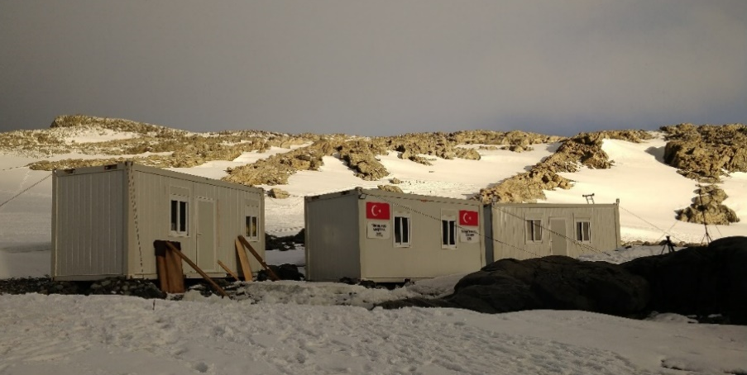
Figure 1. Turkish Scientific Research Camp
The Camp Site
In the Initial Environmental Evaluation (IEE) report prepared for the camp, it was stated that the established camp will be used for three seasons and removed after the realization of the projects in 2022. However, in the draft Comprehensive Environmental Evaluation (CEE) report for the construction and operation of the Turkish Antarctic Research Station (TARS) at Horseshoe Island, it was informed that “the already existing Turkish Scientific Research Camp modules will be integrated to the TARS construction camp”. The emergence of the Covid-19 pandemic in 2020 adversely affected the polar research activities worldwide. Under these circumstances, Turkey accomplish to organize the fifth Turkish Antarctic Expedition (TAE-V) in the 2020-2021 Antarctic season with a limited number of researchers in order to provide the sustainability of former research activities by taking all necessary health measures.
Conclusion
Considering the impact of the Covid-19 pandemic on the global economy, potential disruptions in supply and logistics of construction materials, increasing costs, and the safety of the personnel, the construction of the new station is planned to be commenced after the mentioned global concerns are over. Therefore, Turkey declares that the Turkish Scientific Research Camp will be used until the new station is put into service.

