Discovery of the wreck of Endurance - Updating information for HSM 93 and Development of a Management Plan

Discovery of the wreck of Endurance - Updating information for HSM 93 and Development of a Management Plan
A Working Paper submitted by the United Kingdom and South Africa
Summary
This paper proposes to update information in the listing of HSM 93, Wreck of Endurance, following its discovery on 5 March 2022. Recalling Resolution 2 (2021) and Decision 1 (2021) the United Kingdom and South Africa recommend that the Committee:
- Recommends the ATCM adopts a Measure (draft at Annex II) to update the ‘Description’, ‘Site Location’, ‘Conservation Status’, ‘Management Tools’, and ‘Physical features of the environment and cultural and local context’ information fields of HSM 93; and
- Notes that a Management Plan will be developed for HSM 93, now that the wreck has been located.
Background
The wreck of the Endurance, the vessel owned and used by Sir Ernest Shackleton during his 1914-16 Imperial Trans-Antarctic Expedition, was designated an Historic Site & Monument (HSM) through Measure 12 (2019). At the time of designation the actual location of the wreck was unknown. However the Endurance’s skipper and master navigator, Captain Frank Worsley, recorded the coordinates of the location of sinking of the ship, and these were included in the original HSM designation.
Endurance22 Expedition
The British-led Endurance22 expedition set out from Cape Town, South Africa on 5 February 2022 with the aim to locate, identify and survey the wreck of Sir Ernest Shackleton’s ship Endurance, which was trapped and crushed by the ice and sank in the Weddell Sea in 1915. Embarked on board the South African vessel S.A. Agulhas II, the Endurance22 expedition team used SAAB Sabertooth underwater vehicles to search for the wreck.
On 5 March 2022, the Endurance22 expedition found the Endurance at a depth of 3,008 metres in the Weddell Sea at location 68°44'21'' S, 52°19'47'' W, one hundred years to the day after the burial of Sir Ernest Shackleton.
Description of the shipwreck
The ship was found in a remarkable state of preservation given its fate in 1915. The hull sits upright on the sea bed with many of its recognisable features still visible. The ship’s name and polestar remain emblazoned across the stern, and the ship’s wheel and the anchor chains are still in place. The masts and rigs, which were lost when the ship was crushed by the ice, are, as expected, in a collapsed state. But the pictures show a vessel still very much recognisable.
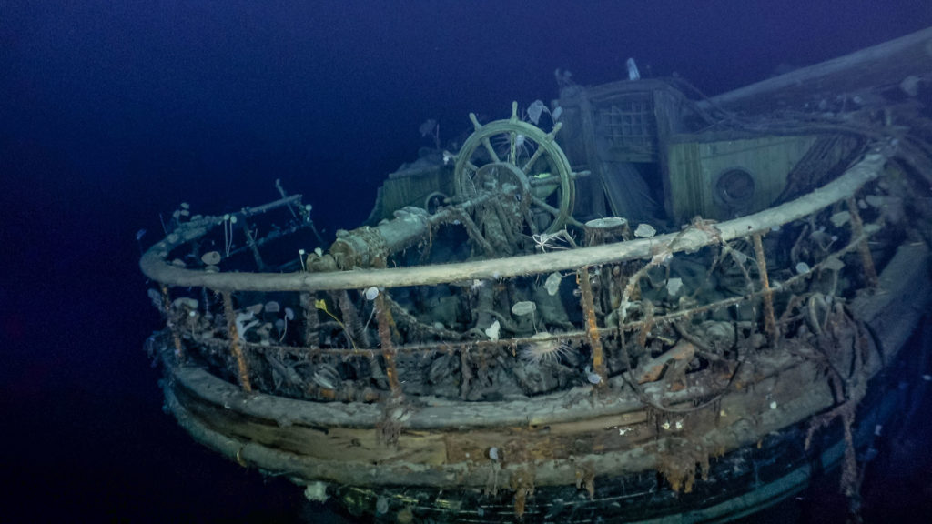
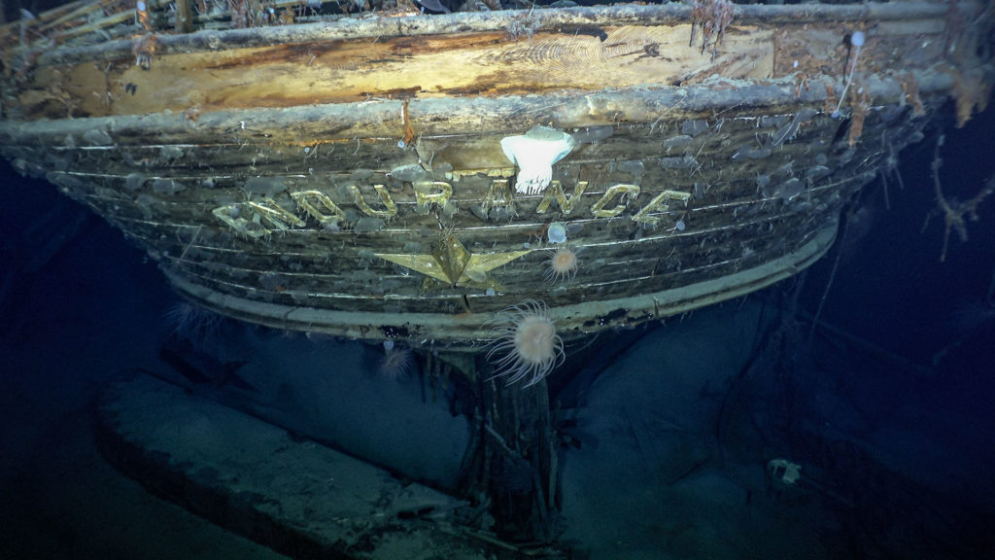
The Endurance22 expedition captured high definition film, 4K resolution photography, and laser scans of the entire wreck. This data will be used for further analysis and will provide unique visual access to the ship 107 years after it was lost to the Weddell Sea. The photographs have been reproduced in this paper with the kind permission of the expedition organisers.
Figure 2. Taffrail and ship’s wheel on aft well deck
Figure 1. The stern of the Endurance with her name and emblematic polestar in brass.
Observed Biodiversity
The images obtained by the expedition have also provided opportunity for study of biodiversity colonising the wreck. British Antarctic Survey scientists have studied the video from the wreck, and determined that the Endurance is home to a wide variety of sessile, filter feeding animals and what appears to be a type of squat lobster. The filter feeding animals include many large sea anemones, a stalked crinoid (sea lily), numerous tunicates (sea squirts), probable hydroids, and glass sponges (Hexactinellidae) - all of which are classed as vulnerable marine ecosystem (VME) taxa by CCAMLR, and a six-armed brisingid starfish. In addition to the filter feeding animals, several decapod crustaceans, most likely squat lobsters from the genus Munidopsis, were observed on the decks of the ship, although further identification for all the animal groups will require higher resolution images.
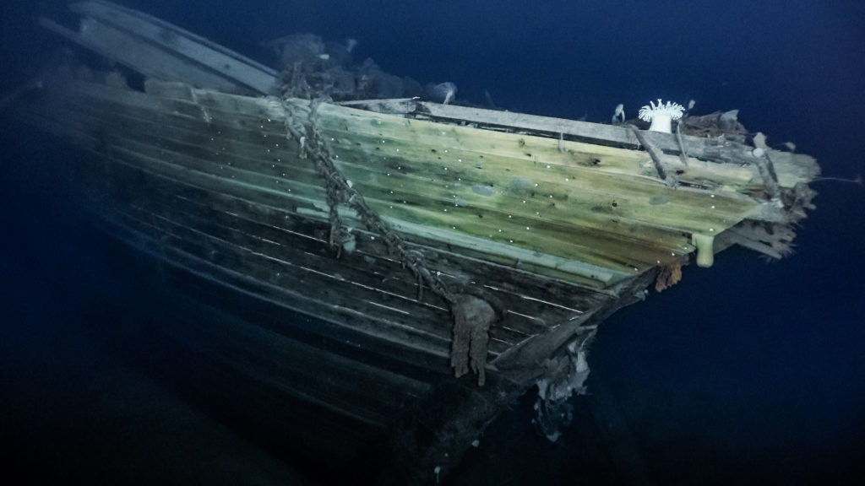
Whilst the discovery of marine life on the wreck after 107 years is not unexpected, the observations represent the second ever record of a squat lobster within Antarctic waters, and the first for the cold waters of the Weddell Sea. Knowing the date of the sinking also offers scientists a unique timeframe for natural colonisation of hard substrates and growth rates of important animal groups in the Antarctic deep sea. The remarkable preservation of the timbers of the ship also supports previous theories that wood eating organisms (such as shipworms a burrowing type of bivalve mollusc), commonly found elsewhere in the world's oceans, are absent from Antarctic waters due to the lack of any nearby forests on the land.
Figure 3. Starboard bow
Updating the record for HSM 93
Now that the wreck has been located, we can provide updated information for the listing of HSM 93. On advice from the International Polar Heritage Committee (IPHC) and International Committee on Underwater Cultural Heritage (ICUCH), it is also recommended that the area encompassed by the HSM listing is expanded from 150m to 500m radius. This is in recognition that the current 150m radius is likely insufficient to capture all of the historic material that will have dispersed while dropping through more than 3,000m of water.
Development of a Conservation Management Plan
The Endurance has been located in a well-preserved state, and its discovery has generated considerable heritage and scientific interest. In line with best practice for HSMs, the UK therefore plans to develop a Conservation Management Plan as a guiding document for the conservation and management of the wreck, as well as to consider any additional forms of protection that may be required. The Conservation Management Plan will be developed during the 2022-2023 intersessional period, in consultation with relevant expert bodies including the IPHC, ICUCH and other interested organisations, and presented to CEP XXV.

Recommendations
The United Kingdom and South Africa recommend that the Committee:
- Recommends the ATCM adopts a Measure (draft at Annex II) to update the ‘Description’, ‘Site Location’, ‘Conservation Status’, ‘Management Tools’, and ‘Physical features of the environment and cultural and local context’ information fields of HSM 93; and
- Notes that a Conservation Management Plan will be developed for HSM 93, now that the wreck has been located.

ANNEX I
COVER SHEET FOR A WORKING PAPER ON A HISTORIC SITE OR MONUMENT
1. Has this site or monument been designated by a previous ATCM as a Historic Site or Monument?  (If yes, please list the relevant Recommendations and Measures.) | Yes – Measure 12 (2019)
2. If the proposal is for a new Historic Site or Monument, please include the following information, worded for inclusion in the Measure: | N/A
(i) Name | N/A
(ii) Description  Describe materials, construction, function, use. | N/A
(iii) Site Location:  Provide one latitude and one longitude coordinate only. | N/A
(iv) Designation/ Amendment | N/A
(v) Original proposing Party  List proponent(s) | N/A
(vi) Party undertaking management:  Name the country/countries which are committed to following up (with management approach specified for the object/site) | N/A
(vii) Type  • building (hut, station, other building remains),  • site,  • commemorative item (plaque, bust, cross, other) or  • other remains (expedition cairn, tent, lighthouse, shipwreck, other). | N/A
(viii) Conservation status | N/A
(ix) Description of the historical context | N/A
(x) Applicable criteria in accordance with Resolution 3 (2009): | N/A
(xi) Management tools:  Describe management and/or monitoring actions planned for the object/site in question – cf. Section 6 and 7, as well as pt. 5 in Annex to Resolution 3 (2009), as well as measures that will be taken to limit any environmental impacts that the management of the HSM may cause. It will not always be appropriate to have a formal management plan, but this can be noted in the proposal. | N/A
(xii) Photos:  Provide images, preferably with short captions and picture credits, showing the site and/or monument and its location/surroundings. | N/A
(xiii) Physical features of the environment and cultural and local context | N/A
3. If the proposal is to revise an existing designation of an HSM, please list the relevant past Recommendations and Measures. | Recalling Resolution 2 (2021) and Decision 1 (2021), the proposal is to amend the information in the listing of HSM 93 (Wreck of Endurance), designated through Measure 12 (2019).

Annex II
Draft Measure
Revised List of Antarctic Historic Sites and Monuments: Updating information for HSM 93, Wreck of Endurance

The Representatives,
Recalling the requirements of Article 8 of Annex V to the Protocol on Environmental Protection to the Antarctic Treaty to maintain a list of current Historic Sites and Monuments (“HSMs”) and that such sites shall not be damaged, removed or destroyed;
Recalling
- Measure 12 (2019), which added the wreck of the Endurance to the list of HSMs;
- Resolution 2 (2021), which revised the Guide to the Presentation of Working Papers containing proposals for Antarctic Specially Protected Areas, Antarctic Specially Managed Areas or Historic Sites and Monuments; and
- Decision 1 (2021), which set out the information contained in fields that continue to be a formal part of the List of HSMs and that changes to these fields will require adoption through a Measure;

Recommend to their Governments the following Measure for approval in accordance with paragraph 2 of Article 8 of Annex V to the Protocol on Environmental Protection to the Antarctic Treaty:
That the information in the HSM listing for HSM 93, Wreck of Endurance, be amended as in the table below:
Field | Current Text | New Text
(i) Name | Wreck of Endurance | No change to current text
(ii) Description  Describe materials, construction, function, use. | Wreck of the vessel Endurance, including all artefacts contained within or formerly contained within the ship, which may be lying on the seabed in or near the wreck within a 150m radius. This includes all fixtures and fittings associated with the ship, including ship’s wheel, bell, etc. The designation also includes all items of personal possessions left on the ship by the ship’s company at the time of its sinking. | Wreck of the vessel Endurance, including all artefacts contained within or formerly contained within the ship, which may be lying on the seabed in or near the wreck within a 500m radius. This includes all fixtures and fittings associated with the ship, including ship’s wheel, bell, etc. The designation also includes all items of personal possessions left on the ship by the ship’s company at the time of its sinking.
(iii) Site Location:  Provide one latitude and one longitude coordinate only. | 68° 39' 29.9987" S, 52° 26' 30" W | 68°44'21'' S, 52°19'47'' W
(iv) Designation/ Amendment | M 12 (2019) | No change to current text
(v) Original proposing Party  List proponent(s) | United Kingdom | No change to current text
(vi) Party undertaking management:  Name the country/countries which are committed to following up (with management approach specified for the object/site) | United Kingdom | No change to current text
(vii) Type  • building (hut, station, other building remains),  • site,  • commemorative item (plaque, bust, cross, other) or  • other remains (expedition cairn, tent, lighthouse, shipwreck, other). | Other remains: shipwreck | No change to current text
(viii) Conservation status | The condition of the ship is currently unknown | Appears to be well preserved.
(ix) Description of the historical context | Endurance was the vessel owned and used by Sir Ernest Shackleton during his 1914-16 Trans-Antarctic Expedition. Endurance became beset in the sea ice before being crushed and eventually sinking to the sea floor in 1915. What followed was a daring rescue by Shackleton by taking the lifeboat James Caird to South Georgia to fetch help. All the men marooned on Elephant Island were saved and retuned home in 1916. | No change to current text
(x) Applicable criteria in accordance with Resolution 3 (2009): | a) a particular event of importance in the history of science or exploration of Antarctica occurred at the place  b) a particular association with a person who played an important role in the history of science or exploration in Antarctica  c) a particular association with a notable feat of endurance or achievement | No change to current text
(xi) Management tools:  Describe management and/or monitoring actions planned for the object/site in question – cf. Section 6 and 7, as well as pt. 5 in Annex to Resolution 3 (2009), as well as measures that will be taken to limit any environmental impacts that the management of the HSM may cause. It will not always be appropriate to have a formal management plan, but this can be noted in the proposal. | To be developed upon discovery of the wreck | A Conservation Management Plan is in development.
(xii) Photos:  Provide images, preferably with short captions and picture credits, showing the site and/or monument and its location/surroundings. |  | No change to current text
(xiii) Physical features of the environment and cultural and local context | The exact location of the wreck is unknown as the ship floated in the pack ice for some distance. We know that the wreck is somewhere, approximately 2 miles deep, on the seabed in the Weddell Sea. Location records made by Frank Worsley, Shackleton’s skipper and master navigator, give precise coordinates of the location of sinking of the ship but these have not been verified since 1915. These last known coordinates have been included as the ‘location’. | The wreck is located on the floor of the Weddell Sea at a depth of 3,008m at location 68°44'21'' S, 52°19'47'' W .

